Implementing Web Application Creating UI to interact with Application

|  |  |
| --- | --- |
| Date | 27 October 2022 |
| Team ID | PNT2022TMID29836 |
| Project Name | Customer Care Registry |

1. **Home page**

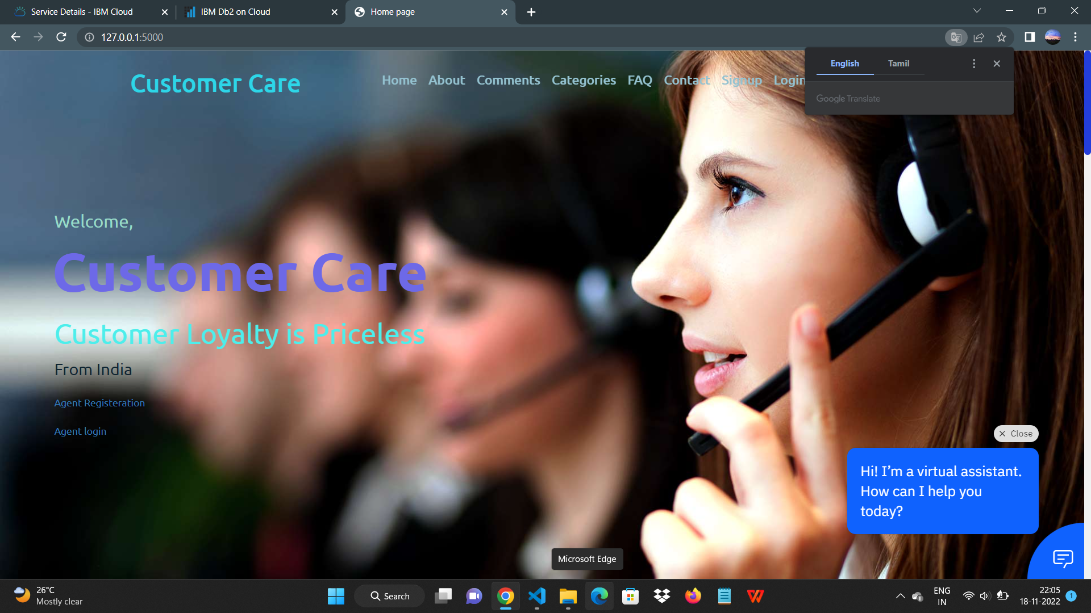

1. **Register page**

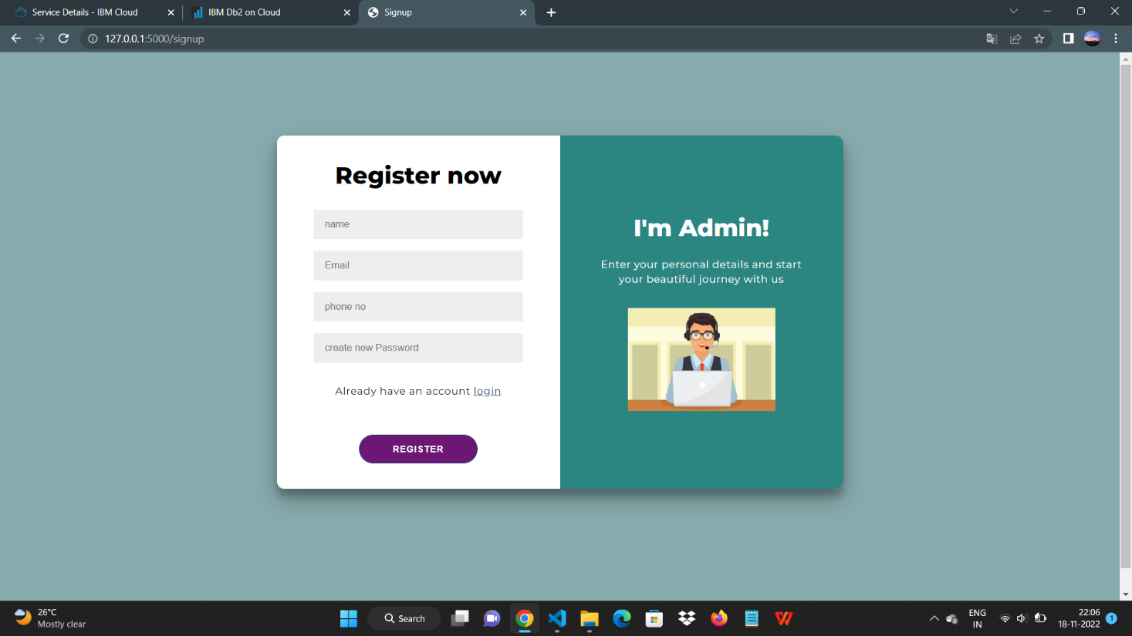

1. **Login Page**

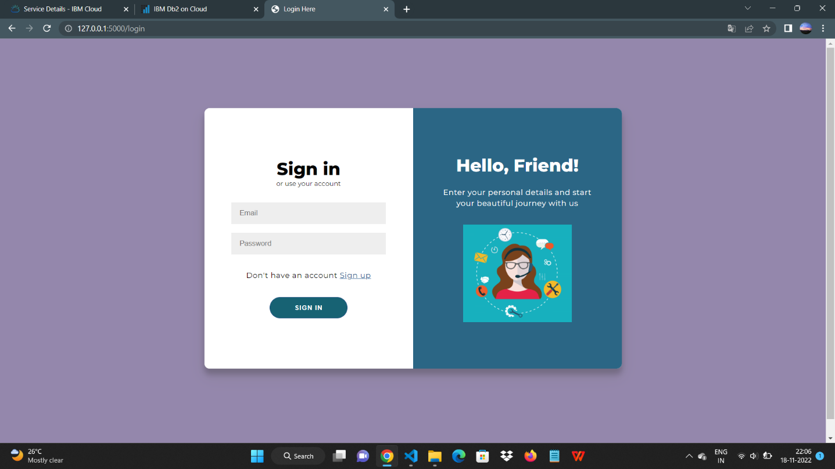

1. **Admin page**

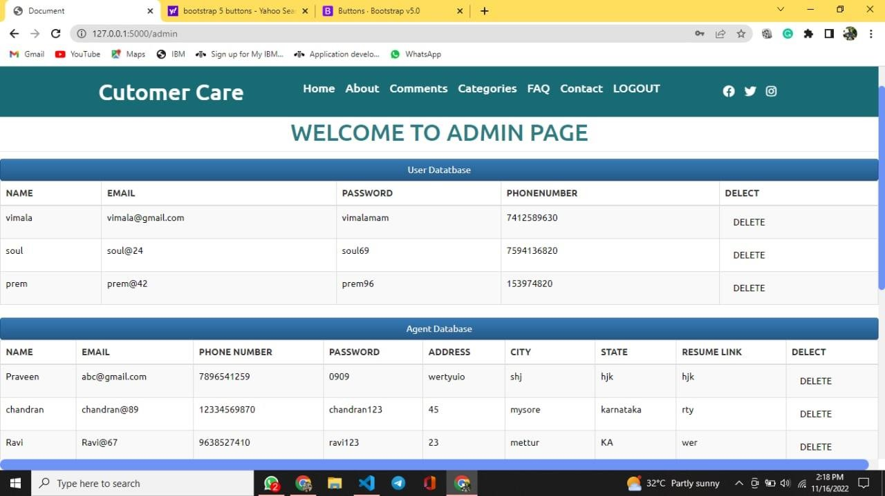

1. **Complaint**

